Task 1. Predator rate

Predator_rate=0.1

birth_rate=0.15

death_rate=0.005

x_coords = [ ]

y_coords = [ ]

For i in range(0, 6):

For j in range(0, population):

If j <= population * birth_rate:

Population += int(triangular(1, 15, 10))

If j <= population * death_rate:

Population -= int(triangular(1, 15, 10))

If j <= population * predator_rate:

Population -= int(triangular(1, 15, 10))

x_coords.append(i * step)

y_coords.append(population)

print(population)

Task 2. Starvation

import matplotlib.pyplot as plt

import math

from random import randint as rand

population=1

starvation_rate_baseline = 0.01

predator_rate=0.1

step=12

birth_rate=0.15

death_rate=0.1

Holocaust=False

Spanish_INQUISITION=False

x_coords = []

y_coords = []

for i in range(0, 100):

if population>0:

current_starvation_rate = starvation_rate_baseline * math.log(population,10)

for j in range(0, population):

if j<=100*birth_rate:

population += int(rand(1,15))

for l in range(0, population):

if rand(0,100)<=100*death_rate:

population -= 1

if rand(0,100)<=100*predator_rate:

population -= 1

if l<=100*current_starvation_rate:

population -= 1

if rand(1,500)==1 and Holocaust!=True:

population -= int(population*0.8)

print("Hitler Did Nothing Wrong")

Holocaust=True

if rand(1,200)==1 and Spanish_INQUISITION!=True:

population -= int(population*0.6)

print("Nobody Expects The Spanish Inquisition")

Spanish_INQUISITION=True

x_coords.append(i * step)

y_coords.append(population)

plt.figure()

plt.plot(x_coords, y_coords)

plt.xlabel("Hours")

plt.ylabel("Population")

plt.title('Tribble Population Growth')

plt.show()

Question 1: In order to create a population that stabilizes what initial values did you use in the model? [2]

Answer:

population=1

starvation_rate_baseline = 0.01

predator_rate=0.1

birth_rate=0.15

death_rate=0.1

Question 2: Which part of the model is most important in stabilizing the population and why? [3]

Answer:

The part which is most important in stabilizing the population is “starvation_rate_baseline” this is because the starvation rate increases along side the growth of the population. Therefore it is a method to prevent the populations for growing exponentially and instead allows the population to balance out around 400 - 500.

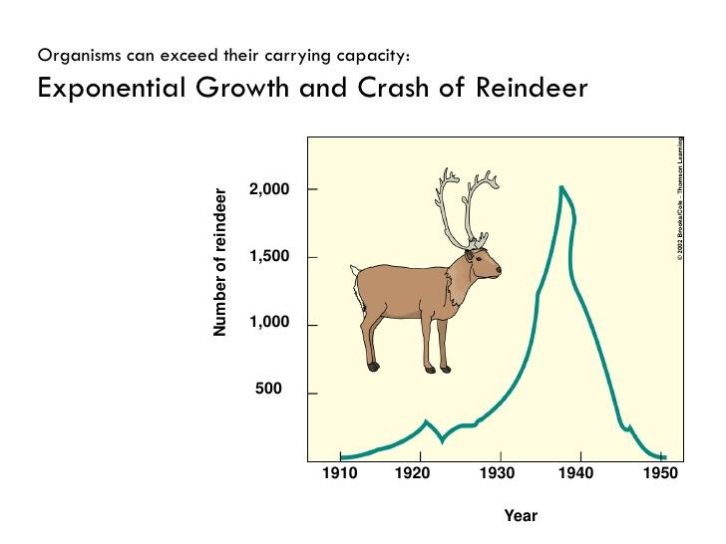

Take a look at the image above which shows the rise and fall of the reindeer population on St. Matthew's island. How might you adapt your current model so that it can model a crashing population? (No need for code) [6]

Have a variable called resources which increases and decreases along with the population, resources mean things such as food, water, etc. Things which the population needs to grow once the population depletes all the resources on the Island all start starving as there is no longer and resources to sustain them. Therefore a population crash would happen.